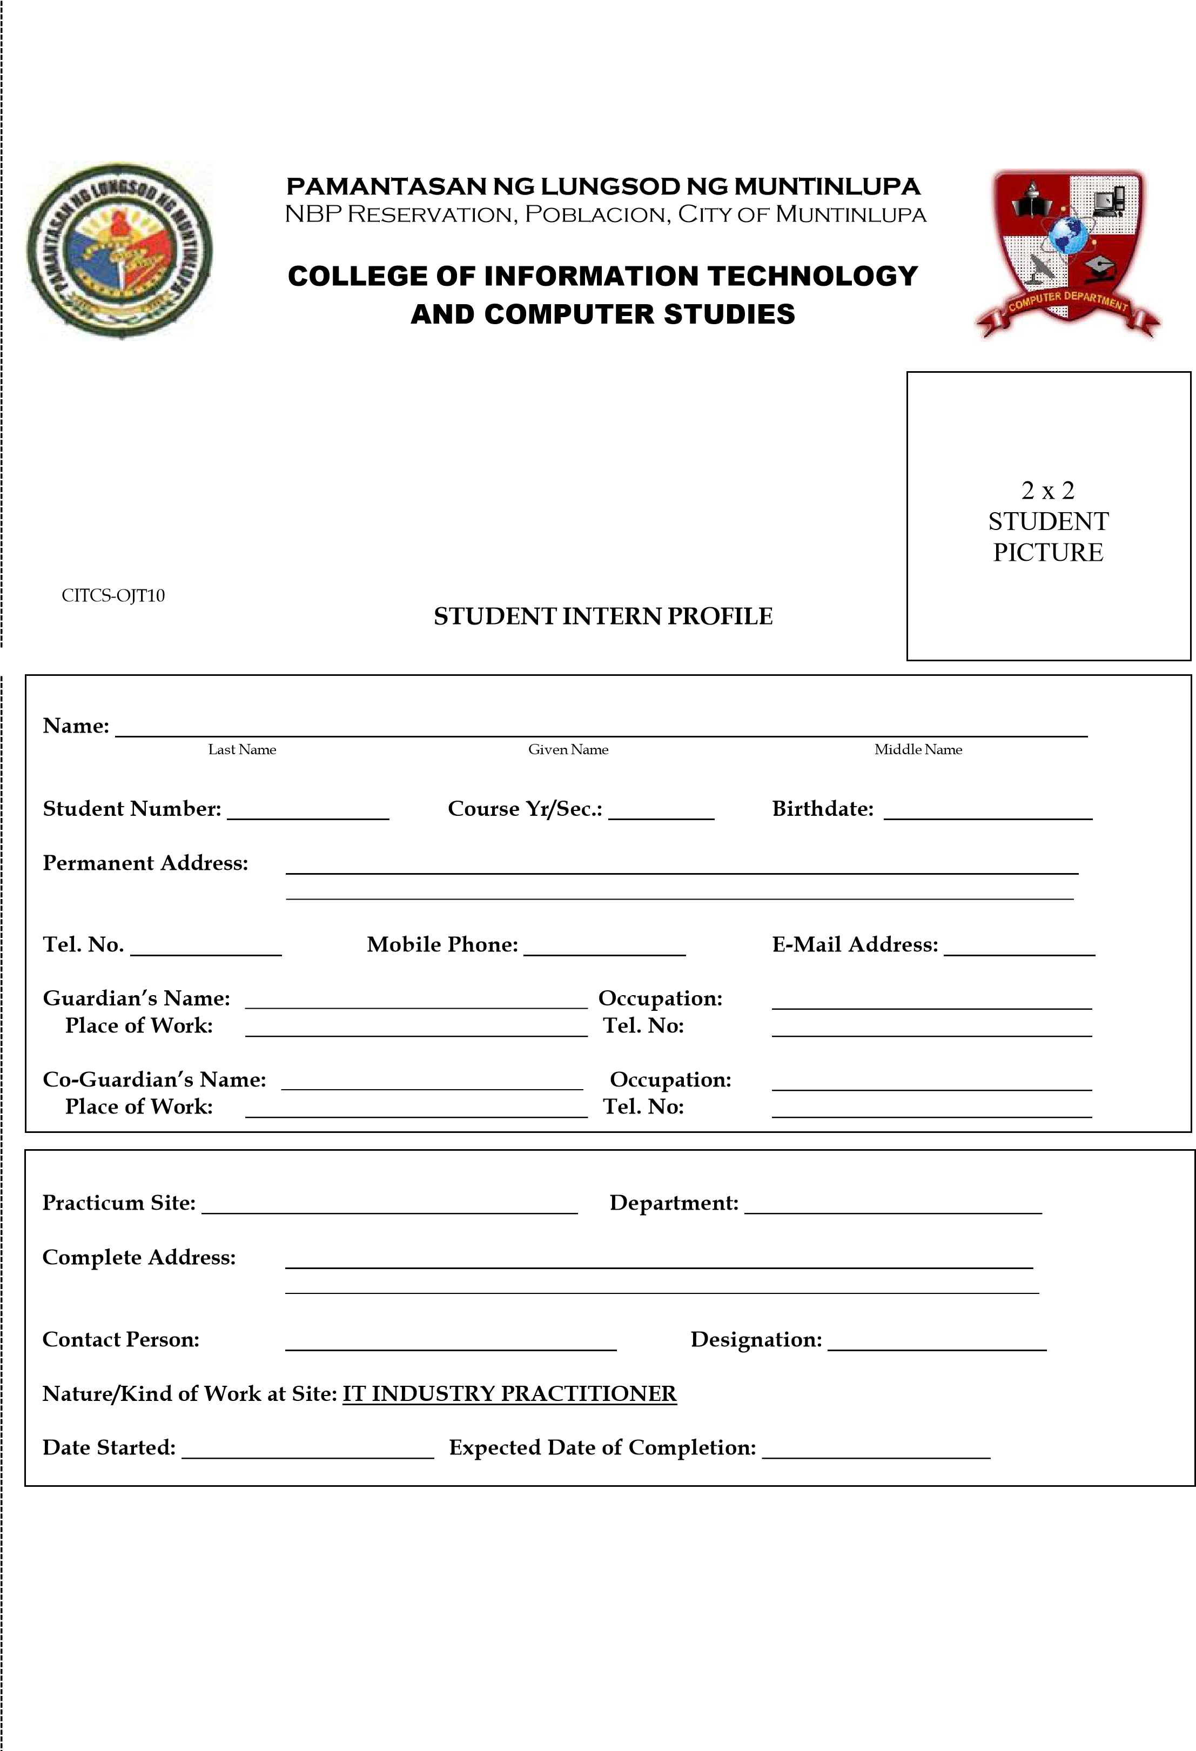

09093561443

Muntinlupa Headquarters

Training PNCO

Dulce A. Aratan

PAT. Marlou Allen C. Nicolas

December 12, 2002

March 22, 2025

February 10, 2025

Training Facilitator

Centennial Avenue, Laguerta, Brgy. Tunasan, Muntinlupa City

09387738207

Muntinlupa City Police Station

Bayanan, Muntinlupa City

Bussiness Man

Wilfredo M. Aratan

Housewife

81San Guillermo Street, Purok 5, Bayanan, Muntinlupa City

N/A

Markclemencearatan  
12@gmail.com

0286386802

09605885849

Avenis

Mark Clemence

Aratan

21136921

CS4C

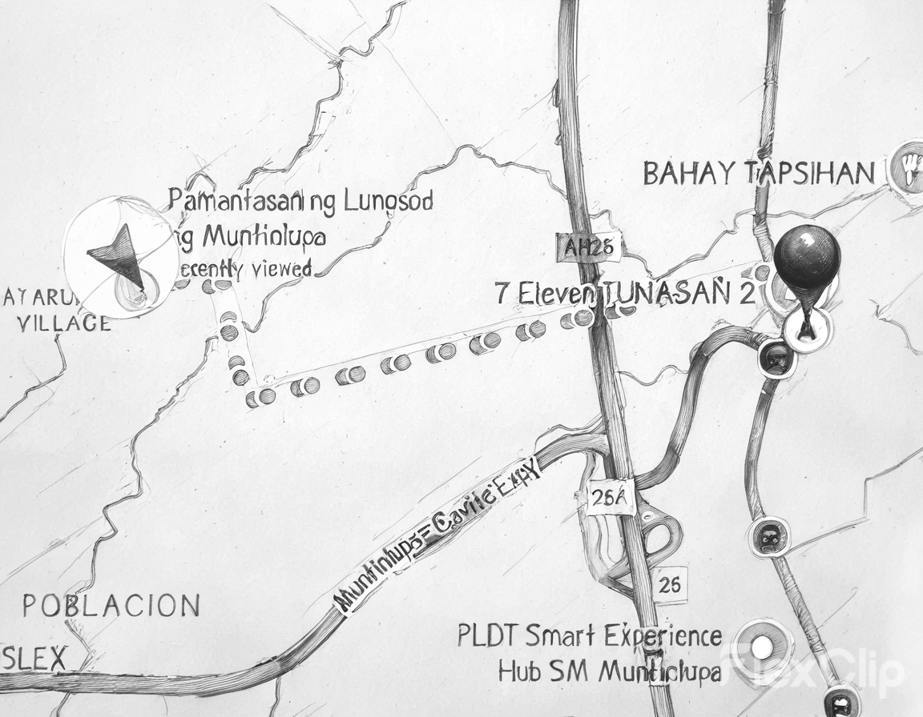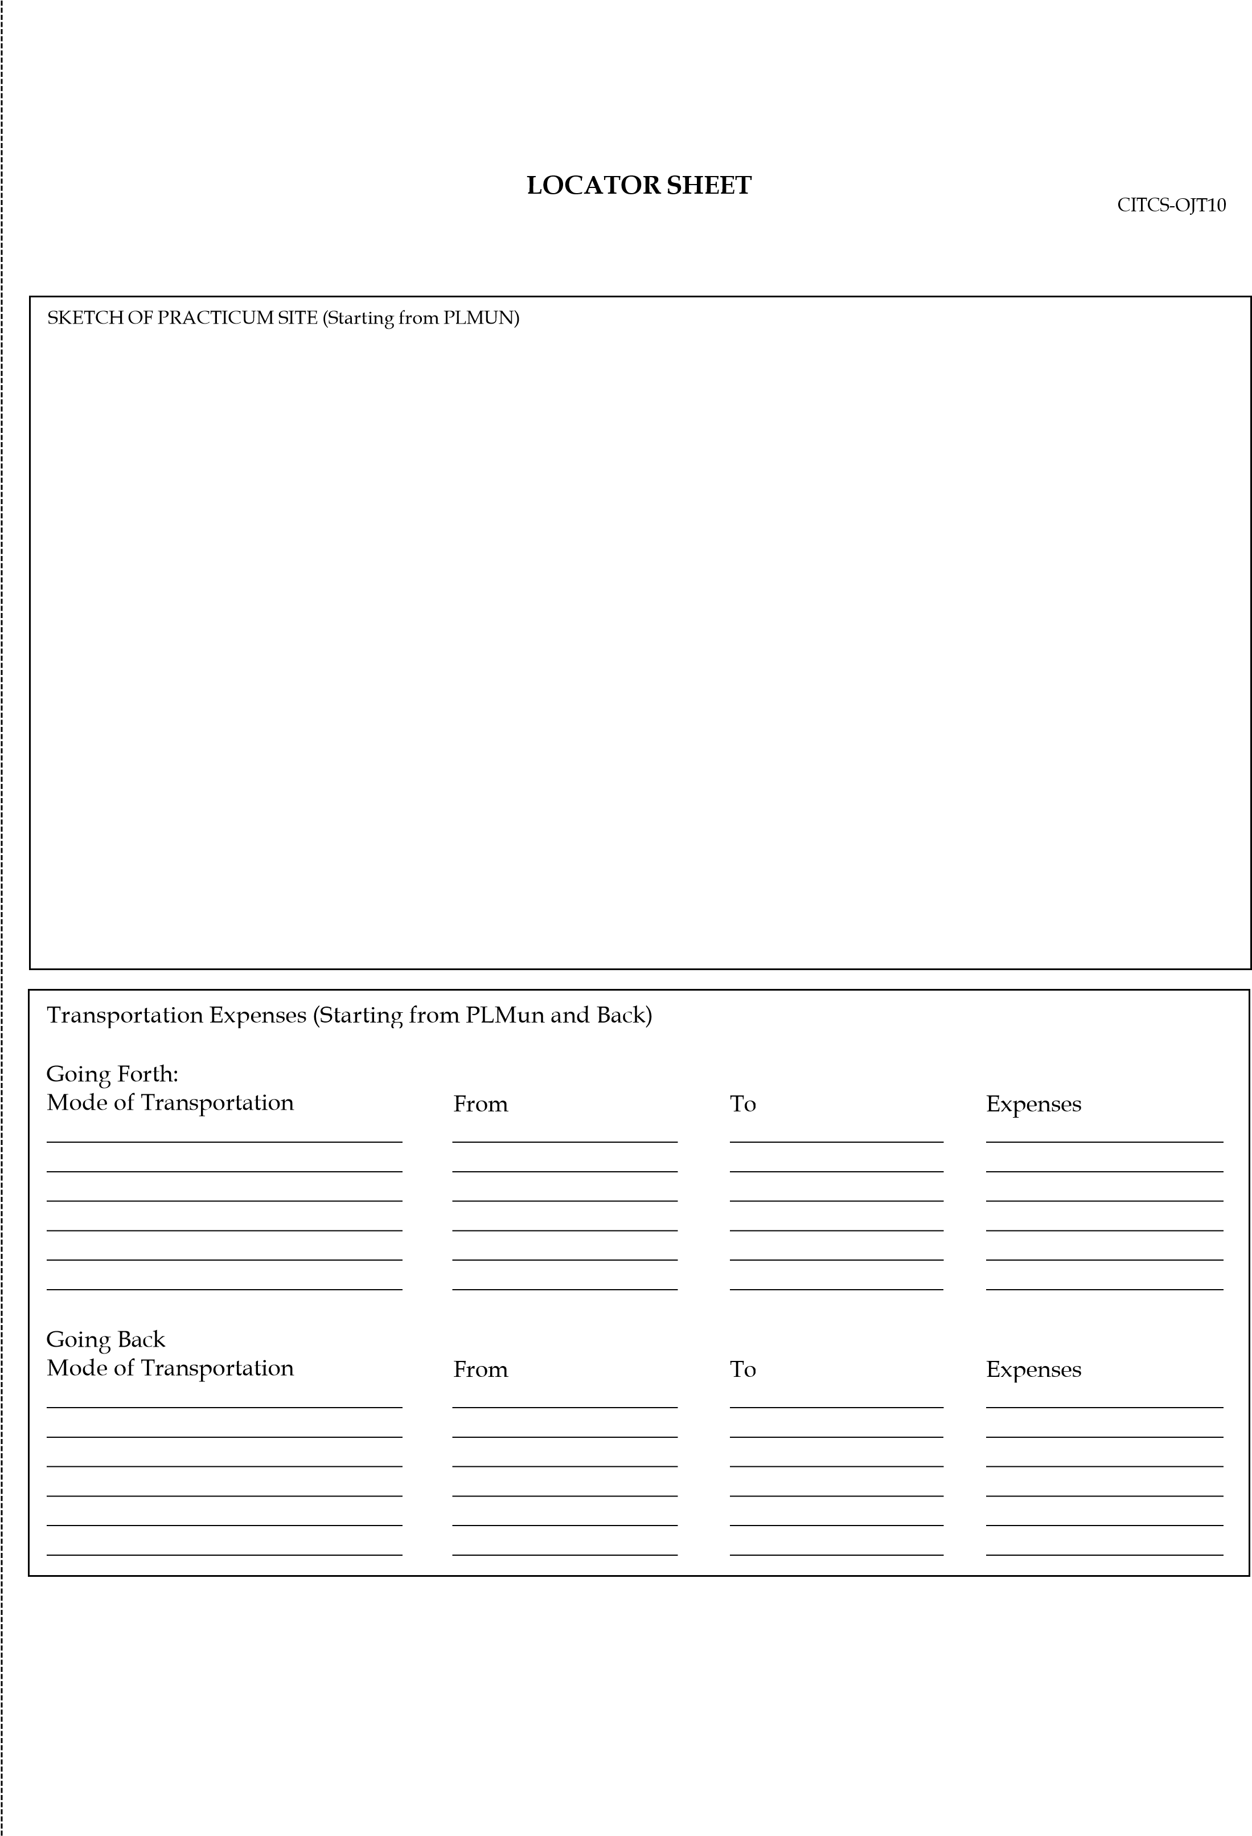

PLMUN

Laguerta

Jamboree Lake

Jamboree Lake

Tricycle or Jeep  
 Tricycle

Tricycle  
Tricycle

Jamboree Lake

Jamboree Lake

Laguerta

University RD

12  
12

12  
12